ALIX
Child of Benny and Tracey Mejia. Lover of baseball, school, and sleeping.
Who Feels Happy To Have a sister.
Who Needs Food and Orange Juice.
Who Fears To Die.
Who Gives Love To God.
Who Would Like To See Rome .
Who Lives In Spring Creek, Nevada

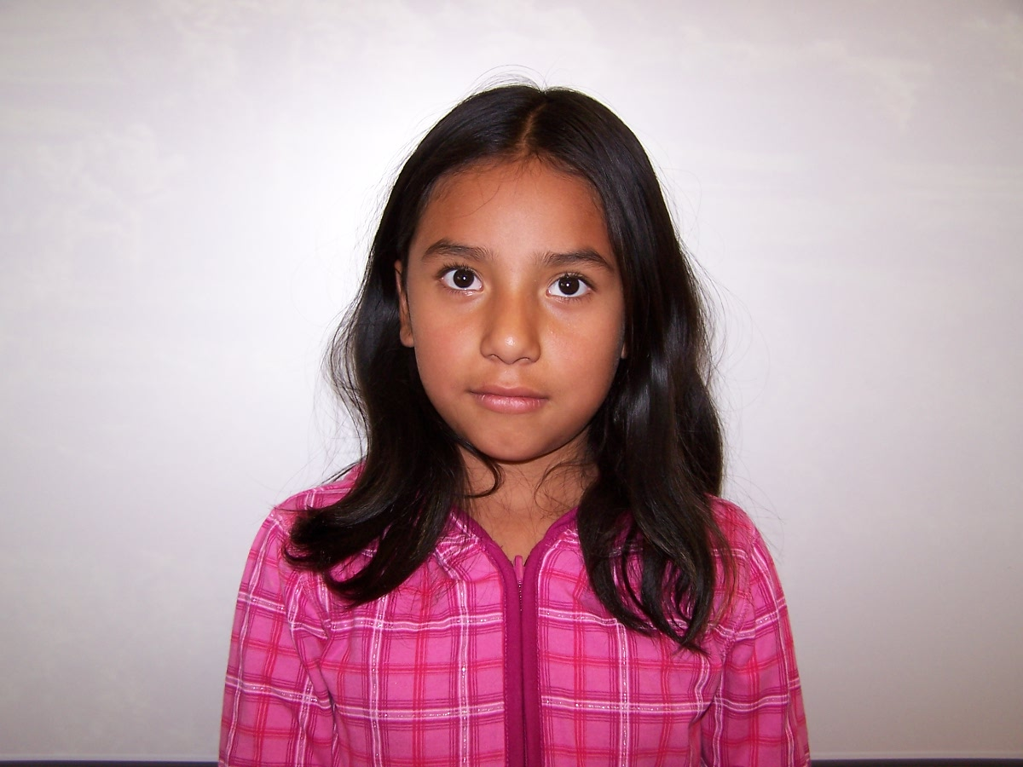

Anthony
Child of Devin and Sontino .
Lover of presents, mom, and dad.
Who feels exited when you are in Sea World .
Who needs food and love each day.
Who fears snakes and sharks.
Who gives a 100% at football practice.
Who would like to see Alaska.
Who lives in Spring Creek ,Nevada
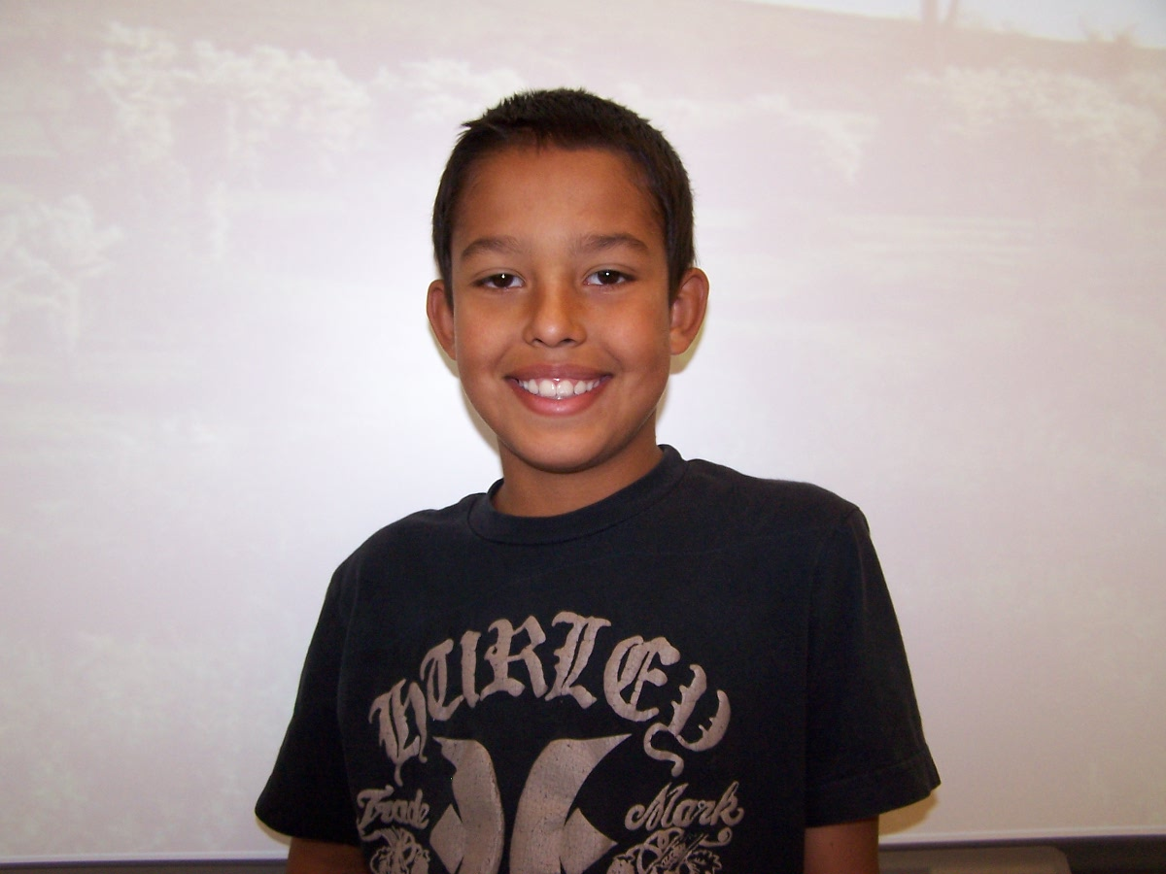
Brayden
Brother of chase
Lover of building, hiking , and fixing.
Who feels sad about our burnt down house.
Who needs someone to talk to.
Who fears all cows.
Who gives money to the fire department.
Who would like to see my uncle for a month.
Who lives in Spring Creek, Nevada.

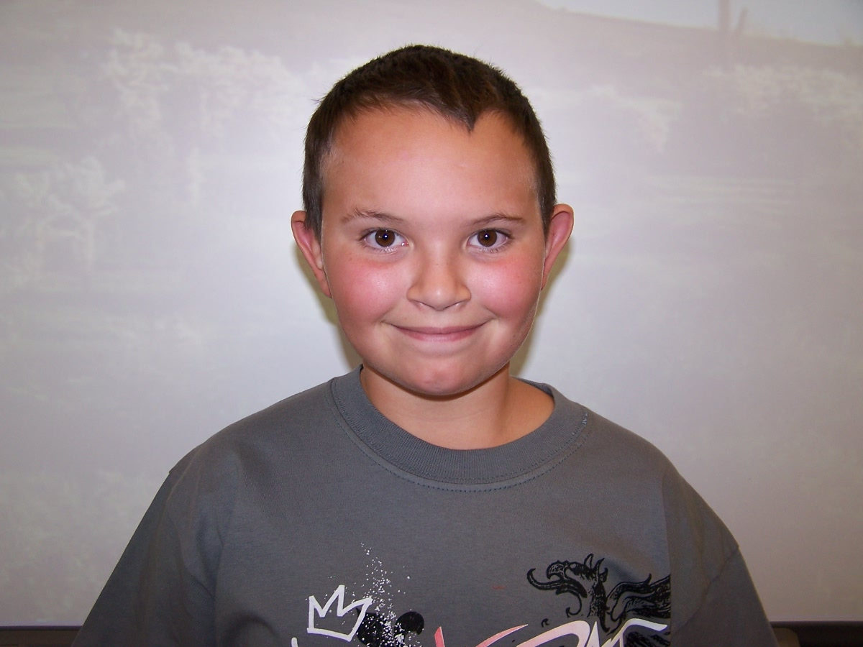

Breeawn
Child of Lindy and Adam.
Lover of school, animals, and family.
Who feels happy when I am with my dogs.
Who needs love, and friendship.
Who fears evil clowns, snakes, and spiders.
Who gives friendship and fun.
Who would like to see Tokyo.
Who lives in Spring Creek, Nevada
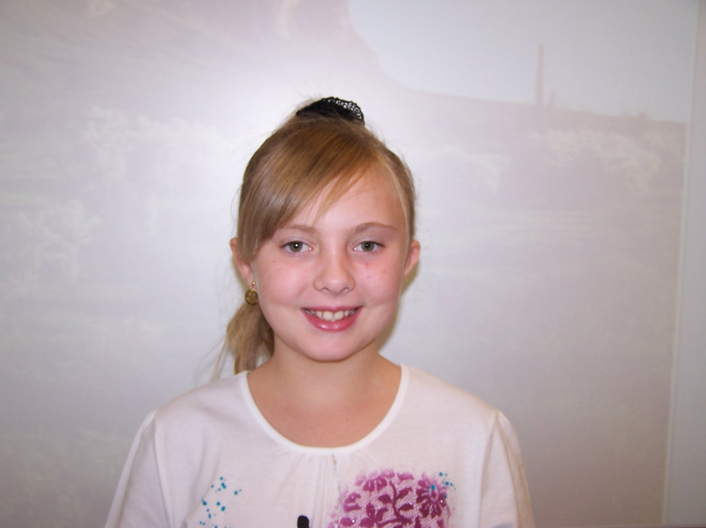
Hannah
Sister of Austin and Gavin
Lover of brownies, cookies, and eggrolls.
Who feels happy when I go to school.
Who needs love everyday and life.
Who fears spiders and helicopters.
Who gives care to people and gives money.
Who would like to see green day.
Who lives in Spring Creek, Nevada.
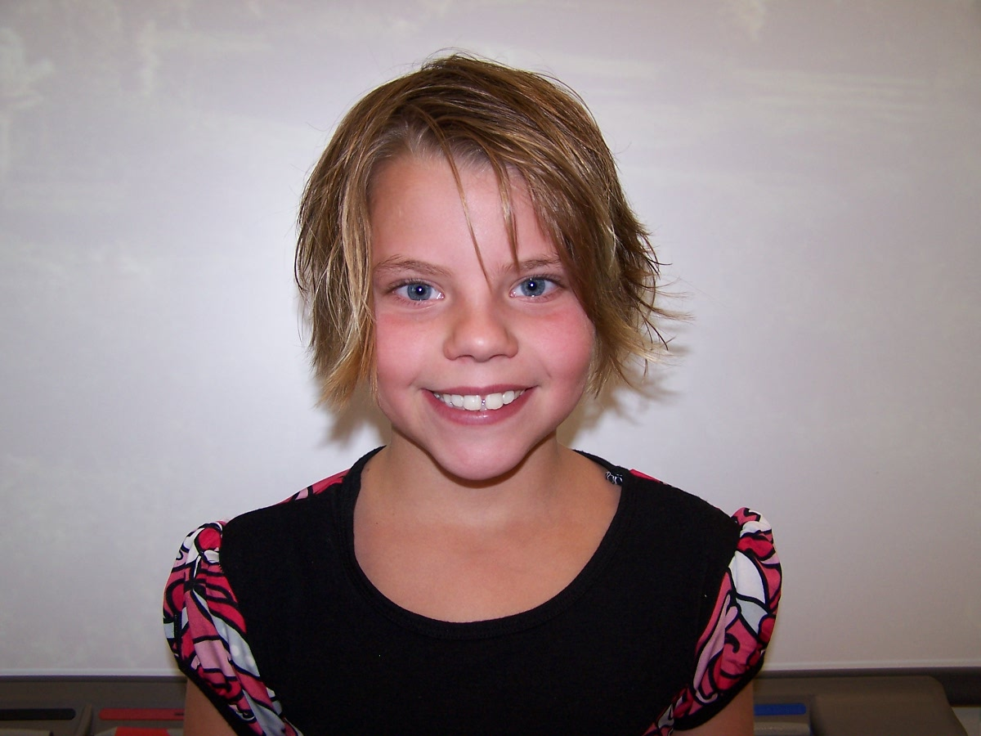

Jessica
Sister of Kessa and Johnny.
Lover of animals, drawing, and sister.
Who feels she wants to have a
little sister.
Who needs a place to run.
Who fears 3D dinosaur movies.
Who gives time and work.
Who would like to see an Elephant seal.
Who lives in Spring Creek, Nevada
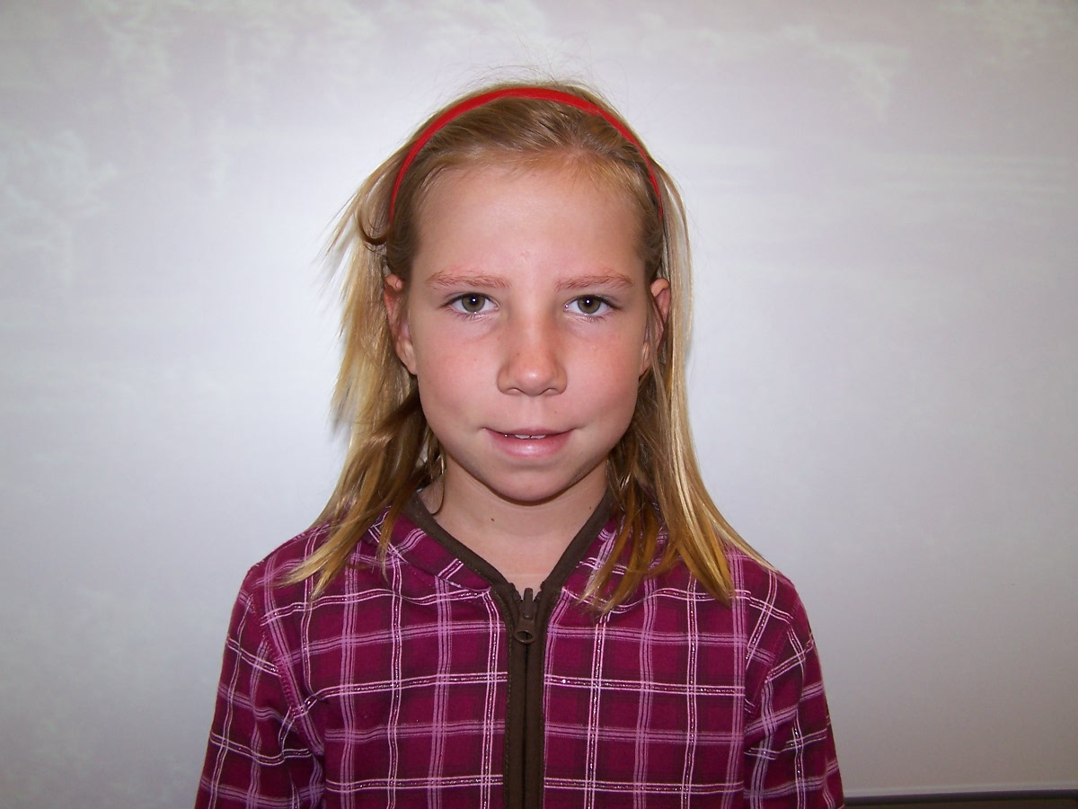
Kayla
Child of Lurie and Phillip
Lover of NASCAR,
Family and cats.
Who feels sad when they fall .
Who needs love From their Parents .
Who fears snakes and spiders .
Who gives presents to my parents .
Who would like to see New York .
Who lives in spring Creek .
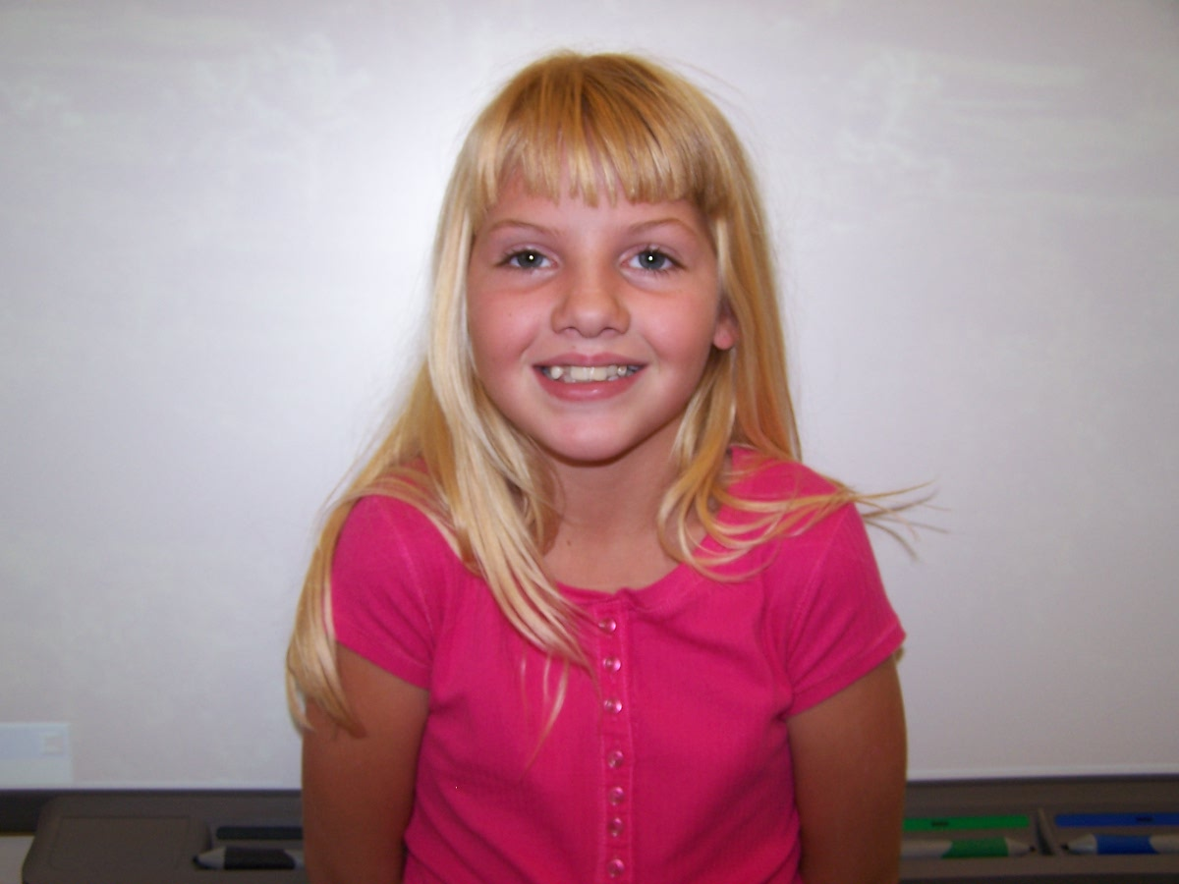
KCI
Son of Ruby and David
Lover of riding, shooting, and fishing.
Who feels tired most of the time.
Who needs someone to play with.
Who fears rattle snakes and bulls.
Who gives money for the walk a thon.
Who would like to see Arizona
and the barn my mom used to live in.
Who live in Spring Creek, Nevada.

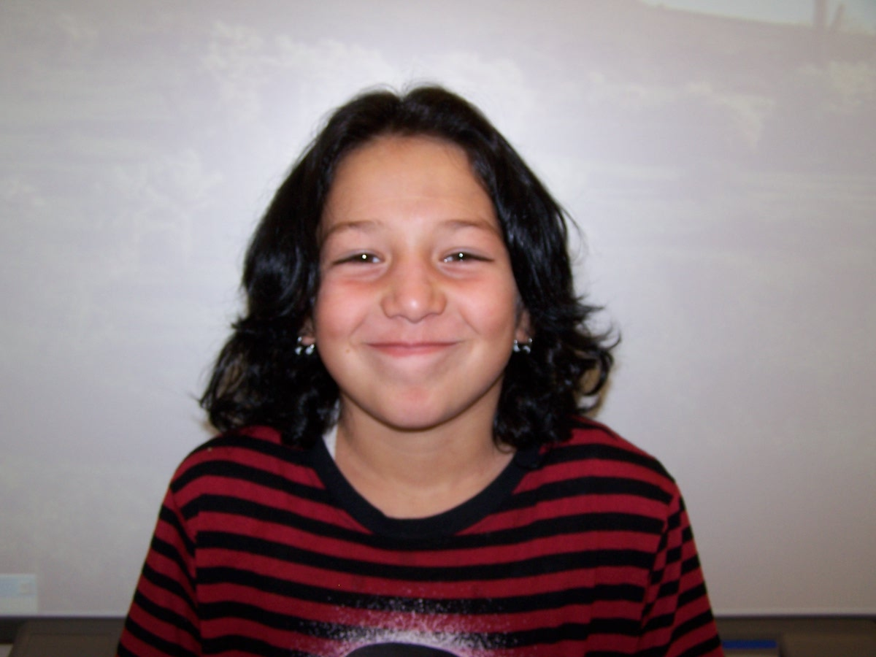
Mitchell
Child of Jess and Tanya.
Lover of Mom, Dad, and brother.
Who feels happy with my family.
Who needs food and love.
Who fears bulls.
Who gives feed to my horses.
Who would like to see Ty Murry.
Who lives in Spring Creek , Nevada.
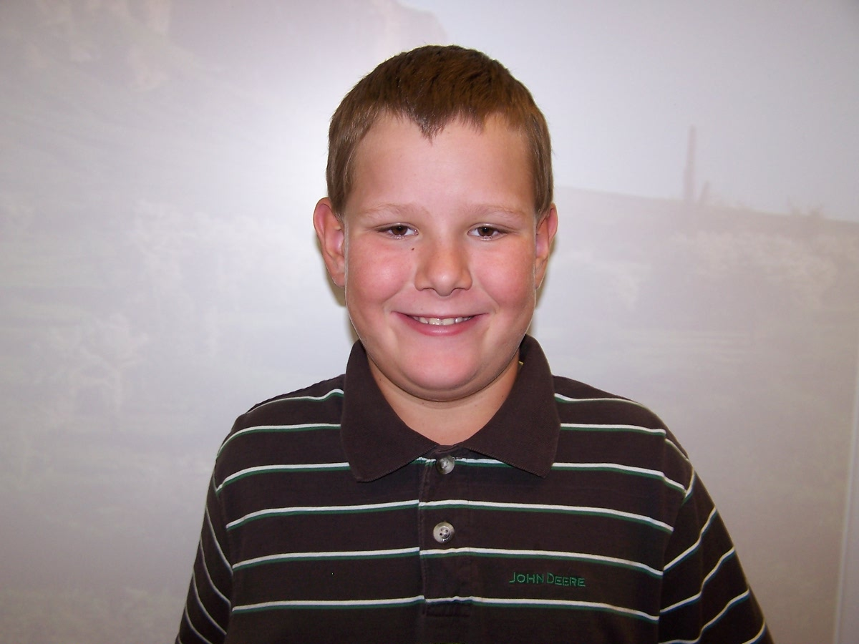

Seth
Son of God.
Lover of imagination, legos, and family.
Who feels sensitive for others.
Who needs love and compassion.
Who gives love to others.
Who would like to see heaven.
Who lives in the galaxy.
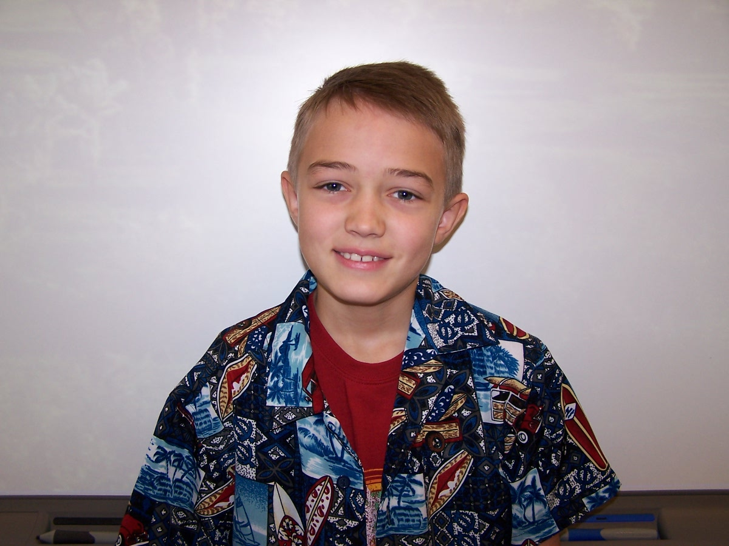

Shelby
Brother of Abbee
Love of Nascar, dogs, and pink.
Who feels happy sometimes.
Who needs food everyday.
Who fears rattlesnakes and boa constrictors.
Who gives presents to my parents.
Who would like to see a real Nascar race.
Who lives in Spring creek Nevada.
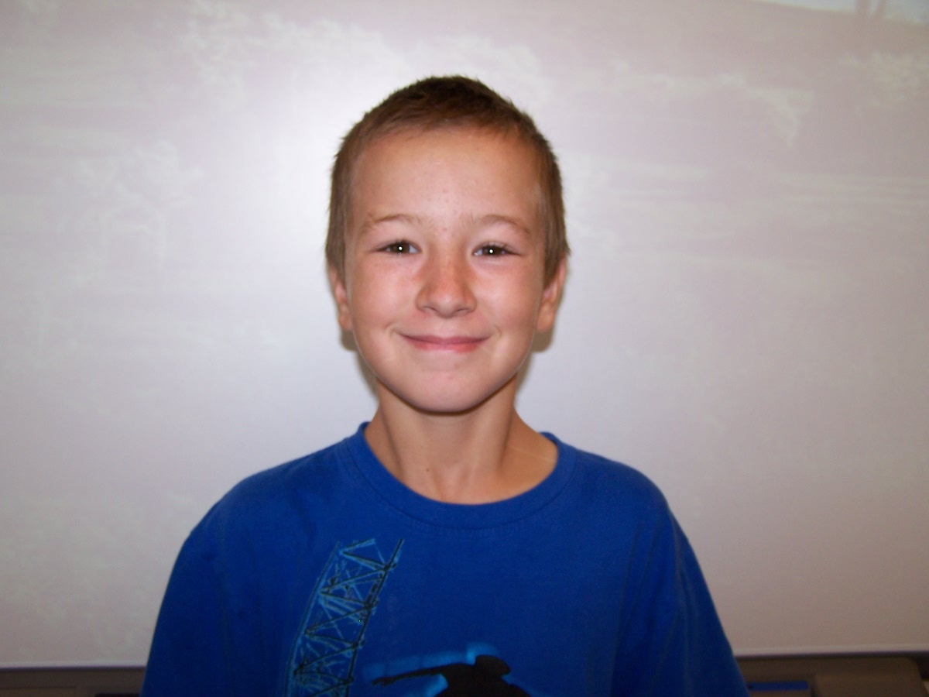

SYDNEY
CHILD OF JESSICA AND KIRT
LOVER OF LEMURES ,DOGS ,AND PANDAS
WHO FEELS HAPPY WITH MY DADDY
WHO NEEDS FOOD ,WATER ,AND LOVE
WHO FEARS EARWIGS AND DEATH
WHO GIVES CARING AND UNDERSTANDING
WHO WOULD LIKE TO SEE HAWAII
WHO LIVES IN SPRINGCREEK NEVADA


